Maximum safety
Integrating smoke detectors via Ei Electronics

Contents
- Allgemein 2
- System 2
- Installation 3
- Programmierung in LUXORplug und LUXORplay 6
- Konfiguration in der LUXORplay App 7

General information

This application example illustrates the integration of smoke and CO detectors from Ei Electronics into the LUXORliving smart home system.
Integration into LUXORliving allows individual actions to be triggered in the event of an alarm. For example, the blinds or roller blinds can be opened automatically, making rescue easier. It is also possible, for example, to switch on the lighting and illuminate escape routes.

 Note: The LUXORliving smart home system is not a life-saving system. The application examples described here are only intended to show the interaction between different solutions and do not release you from your obligation to comply with the legal regulations.

System

The LUXORliving smart home system uses KNX (S-Mode) as communication standard. Various binary inputs allow conventional buttons or switches to be integrated into the system. In addition to typical command devices for controlling the individual system functions, these can also be windows or other signal contacts.
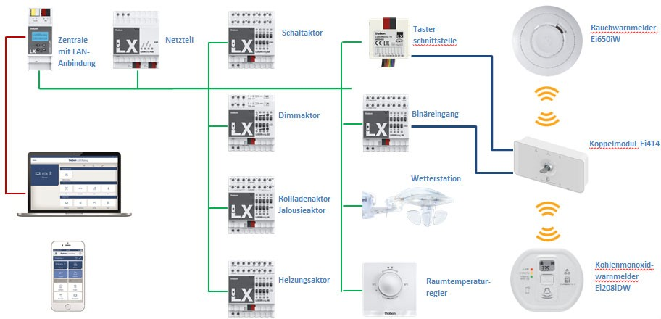

Installation

In this application example, wireless alarm units are integrated via a coupler module and button interfaces. The Ei414 coupler module has separate floating relay outputs for detecting fires and detecting CO. Another floating relay output transmits detector faults and informs you if detectors have been removed from the base without authorisation.
The relay outputs can be connected to the binary inputs (LUXORliving B6, T2, T4 or T8) of the LUXORliving system.
In this application example, a LUXORliving T4 button interface is used to forward the CO and fire warning. You have the option of integrating a fault message into the LUXORliving system via another input or activating the acoustics at all alarms (e.g. in the event of a panic alarm) via a switch contact.

 Before switching on the Ei Electronics coupler module to the LUXORliving system, all alarm units involved must be wirelessly linked to each other.
 Smoke detectors should be positioned according to the recommendations of
DIN 14676-1. Carbon monoxide detectors should be positioned in accordance with the specifications of DIN EN 50292.

Please refer to the respective operating instructions for further information on installation: https://www.theben.de/en/downloads/
https://www.eielectronics.de/service/downloads

Wiring diagram Ei414 to LUXORliving T4

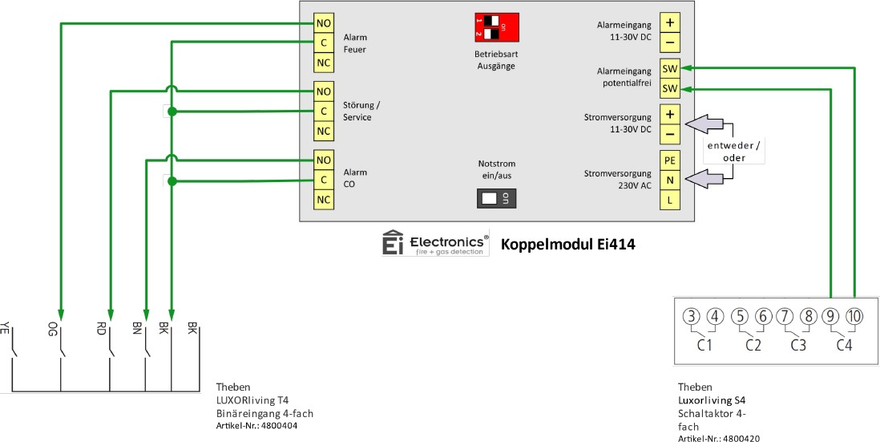

Fire warning:
Connect contact "NO" of relay "Alarm Fire" with input 3 (OG) of the button interface. Connect contact "C" of relay "Alarm Fire" with ground (BK) of the button interface.
Fault message:
Connect contact "NO" of relay "Fault/Service" with input 2 (RD) of the button interface. Connect contact "C" of relay "Fault/Service" with ground (BK) of the button interface.
CO warning:
Connect contact "NO" of relay "Alarm CO" with input 1 (BN) of the button interface. Connect contact "C" of relay "Alarm CO" with ground (BK) of the button interface.
Activating the acoustics of all networked alarm units:
Connect the contacts "SW" of the input "Alarm input floating" with a floating switch contact.
Power supply:
The "Ei414" coupler module can be supplied either with 230 V AC mains voltage or 11-30 V DC low voltage.

 Wiring diagrams for combination with the Ei413 coupler module on pages 8-9

Wiring diagram Ei414 to LUXORliving B6

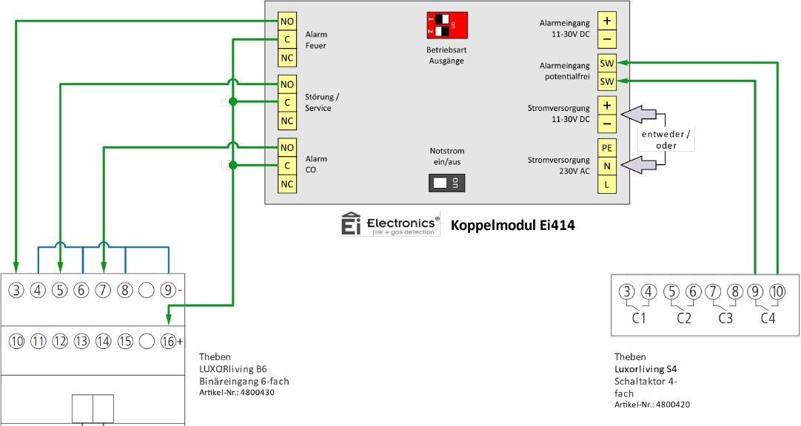

Fire warning:
Connect contact "NO" of relay "Alarm Fire" to input 1 (terminal 3) of the binary input. Connect contact "C" of relay "Alarm Fire" to 12 V DC (terminal +) of the binary input.
Connect terminal 4 of the binary input to 12 V DC (terminal -).

Fault message:
Connect contact "NO" of relay "Fault/Service" to input 2 (terminal 5) of the binary input. Connect contact "C" of relay "Fault/Service" to 12 V DC (terminal -) of the binary input.
Connect terminal 6 of the binary input to 12 V DC (terminal -).

CO warning:
Connect contact "NO" of relay "Alarm CO" to input 3 (terminal 7) of the binary input. Connect contact "C" of relay "Alarm CO" to 12 V DC (terminal +) of the binary input. Connect terminal 8 of the binary input to 12 V DC (terminal -).
Activating the acoustics of all networked alarm units:
Connect the contacts "SW" of the input "Alarm input floating" with a floating switch contact.
Power supply:
The "Ei414" coupler module can be supplied either with 230 V AC mains voltage or 11-30 V DC low voltage.
 Wiring diagrams for combination with the Ei413 coupler module on pages 8-9

Programming in LUXORplug and LUXORplay

The inputs of the LUXORliving T4 button interface can be assigned to any function in the LUXORplug software.
In this application example, the fire warning and the CO warning are used as triggers for individual scenes.
In LUXORplug, the button interface is given a unique name (e.g. warning message) and assigned to any room (e.g. technical room).

Identification and designation of the button interface
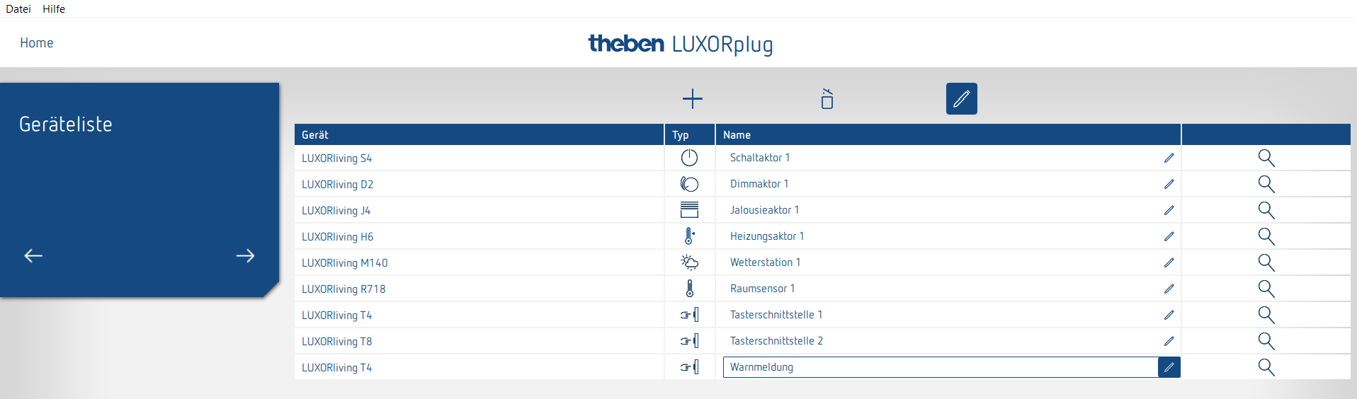

Adding new scene triggers in e.g. technical room.
Connect scene trigger "CO warning" to channel 1 of the button interface Connect scene trigger "Fire warning" to channel 3 of the button interface

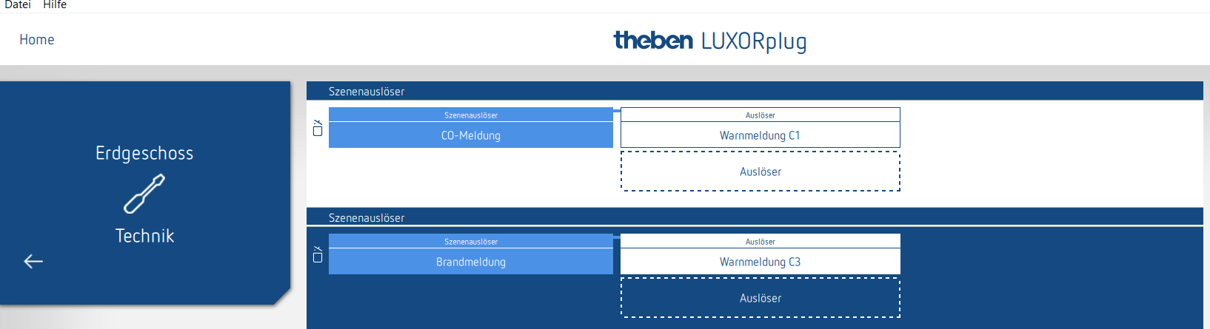

Configuration in the LUXORplay app

In the LUXORplay app, the new "CO warning" and "fire warning" scenes can now be created and the corresponding scene trigger can be selected.
Subsequently, the desired participants for these scenes can be selected. Note that when assigning the participants, the current values and states of the participants for these scenes are automatically saved. When the scene is triggered, the selected participants will assume this saved state.

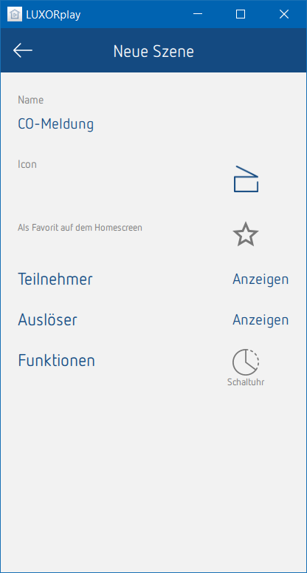
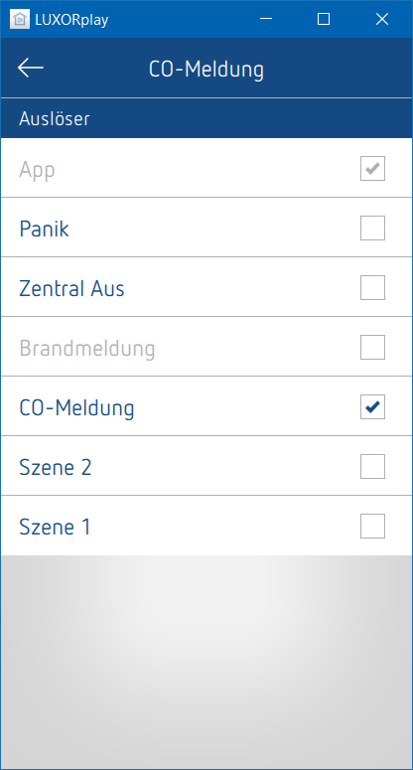
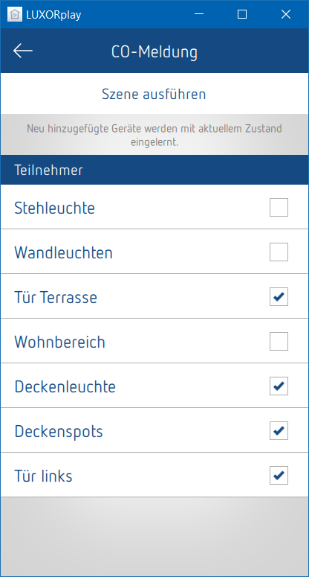

Wiring diagram Ei413 to LUXORliving T4
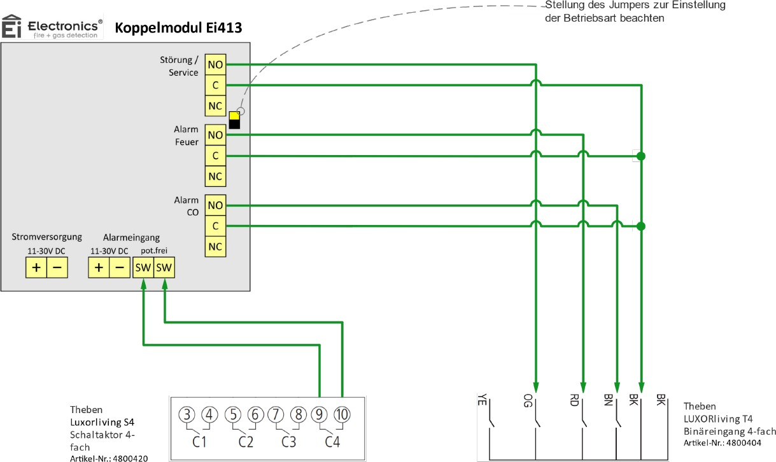

Fault message:
Connect contact "NO" of relay "Fault/Service" with input 3 (OG) of the button interface. Connect contact "C" of relay "Fault/Service" with ground (BK) of the button interface.
Fire warning:
Connect contact "NO" of relay "Alarm Fire" with input 2 (RD) of the button interface. Connect contact "C" of relay "Alarm Fire" with ground (BK) of the button interface.
CO warning:
Connect contact "NO" of relay "Alarm CO" with input 1 (BN) of the button interface. Connect contact "C" of relay "Alarm CO" with ground (BK) of the button interface.
Activating the acoustics of all networked alarm units:
Connect the contacts "SW" of the input "Alarm input floating" with a floating switch contact.
Power supply:
Connect 11-30 V DC supply voltage to terminal "Vin" (+/-) of the coupler relay.

Wiring diagram Ei413 to LUXORliving B6
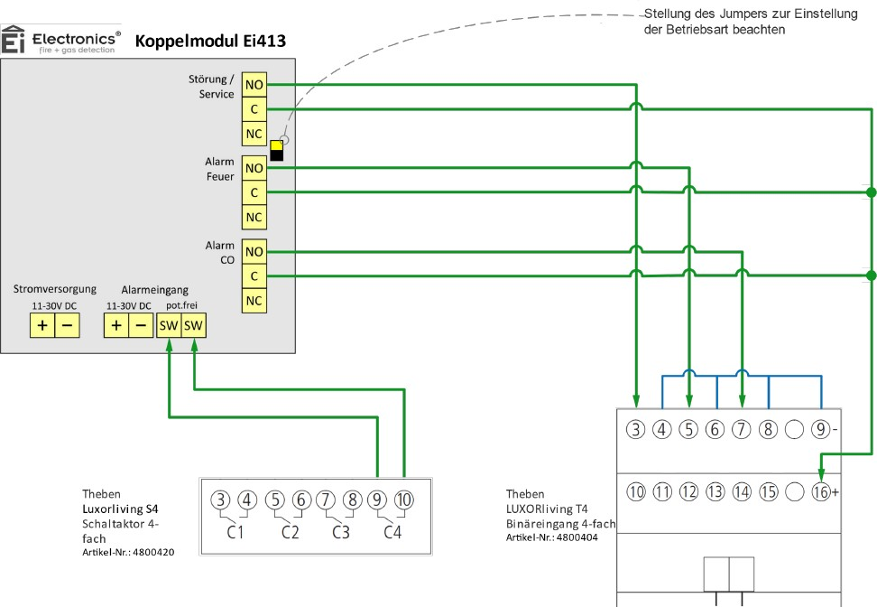

Fault message:
Connect contact "NO" of relay "Fault/Service" to input 1 (terminal 3) of the binary input. Connect contact "C" of relay "Fault/Service" to 12 V DC (terminal -) of the binary input.
Connect terminal 4 of the binary input to 12 V DC (terminal -).

Fire warning:
Connect contact "NO" of relay "Alarm Fire" to input 2 (terminal 5) of the binary input. Connect contact "C" of relay "Alarm Fire" to 12 V DC (terminal +) of the binary input.
Connect terminal 6 of the binary input to 12 V DC (terminal -).

CO warning:
Connect contact "NO" of relay "Alarm CO" to input 3 (terminal 7) of the binary input. Connect contact "C" of relay "Alarm CO" to 12 V DC (terminal +) of the binary input. Connect terminal 8 of the binary input to 12 V DC (terminal -).

Activating the acoustics of all networked alarm units:
Connect the contacts "SW" of the input "Alarm input floating" with a floating switch contact.

Power supply:
Connect 11-30 V DC supply voltage to terminal "Vin" (+/-) of the coupler relay.

